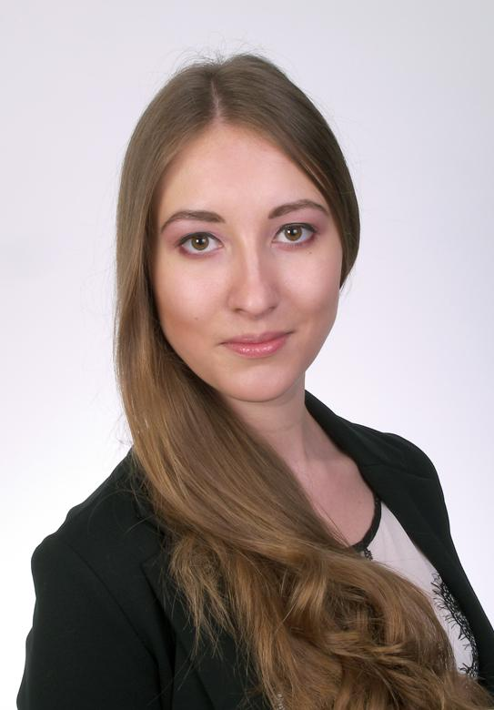

|  |
| --- |
| **Yelyzaveta Shvartsman  Address: Ayanot, Israel (Intend to make Aliyah)**  **Phone: (+972) 5 444 09 433**  **e-mail:** [**eliza.schwartzman@gmail.com**](mailto:eliza.schwartzman@gmail.com) **Skype: eliza.schwartzman** |

**EDUCATION**

2011 - 2014 Cracow University of Economics Bachelor of Applied Informatics (in English)  
2014 - 2017 Cracow University of Economics Master of Business Administration (in Polish)

I am an very well organized, multitask able and self-motivated person. My main goal now is to start career in IT industry (preferably in programming), learn Hebrew as fast as possible and move to Israel. To achieve that I have chosen to join 8 months Masa program “JAVA and Android development”. This program provides every day studying Hebrew and JAVA for 8 hours for 4 months. Thanks to that and my own skills and experience I become well enough prepared junior programmer specialist, that allows me to look for internship in IT industry for the last 4 months of the program.

**PROFESSIONAL EXPERIENCE**

**JCC Krakow (Jewish Community Centre) |** Cracow, Poland  
**May 2016 - April 2017**

**Program associate**

* Database developing and maintaining
* Internet page running
* English-Polish-Russian meetings translation
* Events organization for community and outside publicity
* Public speaking up to 500 people auditory
* Representing organization in public media as TV, radio and magazines
* Presentation, lectures and workshops helding
* Office management, maintenance of main emailbox

**Aon |** Cracow, Poland **January-April 2016  
Internship as a Benefits Platform Administrator**

* Developing an internet platform
* Business analysis
* Data analysis and report writing
* Writing requirements of system functionality
* System testing and fixing system problems
* In cooperation with programmer team building an internet platform
* Technical support to final user
* Taking part in international meetings

**Jewish Culture Festival Society in Krakow** | Cracow, Poland

**June-July 2015**

**Volunteer**

* Preparation for festival in main office
* Organize events, meetings, concerts
* Cleaning and guard the territory of festival area
* Provide souvenir shop
* English-polish translation between artists and television or radio
* Assist one of the bands on backstage during final concert

**Teen Spirit studio, “Orel i Reshka” travel show** | Cracow, Poland

**September 2014**

**Producer assistant**

* Making list of places for filming “Cracov episod”
* Arrange and provide appointments with directors of potential places of filming (museums, churches, hotels, restaurants, etc)
* Translating from ukrainian to polish and english
* Support filming team

**Recreation center «DaLi”** | Azov sea, Kirillovka, Ukraine

**summer 2013, summer 2014**

**Receptionist**

* Organizing meetings, scheduling events
* Reservation service
* Have daily direct and remote connection with clients and customers
* Security and cleaning services administration
* Providing marketing campaign in newspapers and internet
* Creation and support of a website

**SKILLS**

**Languages**:   
English fluent  
Polish fluent  
Hebrew basic   
Russian native  
Ukrainian native

Advanced public speaking

**Computer skills:** Microsoft Office advanced, JAVA, Android, Spring, Hibernate, JSP, git, solid, TDD, design patterns, basics of C, C++, HTML, TCP/IP, SQL, PHP, mySQL  
  
**Personal skills**: Adaptable, cooperative, organized, responsible, honest, people-oriented,analytical, competent, self-motivated